

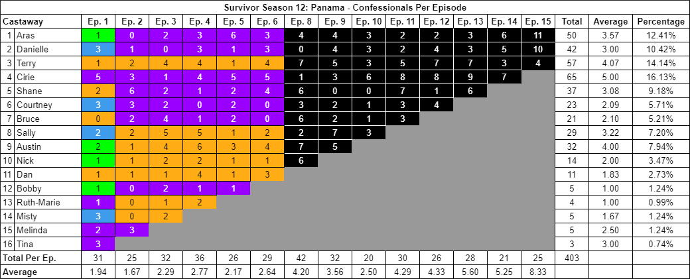

**Survivor 12x01: The First Exile**

**Survivor 12x02: Breakdown**

**Survivor 12x03: Crazy Fights, Snake Dinners**

**Survivor 12x04: Starvation and Lunacy**

**Survivor 12x05: For Cod's Sake**

**Survivor 12x06: Salvation and Desertion**

**Survivor 12x08: An Emerging Plan**

**Survivor 12x09: The Power of the Idol**

**Survivor 12x10: Fight For Your Life or Eat**

**Survivor 12x11: Medical Emergency**

**Survivor 12x12: Perilous Scramble**

**Survivor 12x13: Bamboozled**

**Survivor 12x14: Call the Whambulance!**

**Survivor 12x15: The Final Showdown**